

**ANDROID INSTALLATION AND APK CREATION GUIDE**

|  |  |
| --- | --- |
| **Project Name** | PHmHEALTH |
| **Document Name** | ANDROID INSTALLATION AND APK CREATION GUIDE |
| **Created By** | Ashray Shetty |
| **Created On** | Jun-11-2013 |
| **Updated/Reviewed By** | M B Ashok Kumar |
| **Updated On** | Jun-12-2013 |

Table of Contents

1. INTRODUCTION 3

2. INSTALLING ANDROID 3

2.1 SETUP IDE 3

2.2 DOWNLOAD ANDROID SDK 4

2.3 ECLIPSE SOFTWARE INSTALLATION 5

3. GENERATING APK 5

3.1 RUN ON REAL TIME DEVICE / EMULATOR(VIRTUAL DEVICE) 6

3.2 EXPORTING THE .APK 7

**ANDROID INSTALLATION AND .APK CREATION GUIDE**

# INTRODUCTION

Android **application package file** (**APK**) is the file format used to distribute and install application software and middleware onto Google's Android operating system.

The Android Asset Packaging Tool (aapt) takes your application resource files, such as the AndroidManifest.xml file and the XML files for your Activities, and compiles them.

An R.java is also produced so you can reference your resources from your Java code.

The aidl tool converts any .aidl interfaces that you have into Java interfaces.

All of your Java code, including the R.java and .aidl files, are compiled by the Java compiler and .class files are output.

The dex tool converts the .class files to Dalvik byte code. Any 3rd party libraries and .class files that you have included in your project are also converted into .dex files so that they can be packaged into the final .apk file.

All non-compiled resources (such as images), compiled resources, and the .dex files are sent to the apkbuilder tool to be packaged into an .apk file.

This document describes the steps for installing and setting up the IDE for generating the .APK file for PHmHEALTH project.

# INSTALLING ANDROID

## 2.1 SETUP IDE

To install android on the system, we should first set up an IDE. The preferred IDE is the ECLIPSE.

Below are the steps given to set up the ECLIPSE IDE.

1. Download eclipse IDE from <http://www.eclipse.org/downloads/>.
2. Copy the downloaded ZIP file of eclipse into “C:\Android\” and extract it. We should now have a new folder called "eclipse" in your “Android” folder.
3. Go to <http://www.oracle.com/technetwork/java/javase/downloads/jdk7-downloads-1880260.html> and download the Java SE development kit 7 (JDK 7) for your operating system (can be 32 or 64bit)
4. Install JDK 7.

## 2.2 DOWNLOAD ANDROID SDK

Now we are ready with the IDE, now we need to download the Android Software Development Kit (SDK) that will let you emulate Android on your local computer.

1. Go to <http://dl.google.com/android/installer_r17-windows.exe> the download should start automatically.
2. Once downloaded click on installer_r17-windows.exe to launch the installer.
3. On the first screen of the installation make sure it says "Java SE Development kit (JDK) version 7 has been found" - if not then close installation and repeat step 4 in 2.1.
4. On the next screen of the installation it will ask you for a destination folder, change it to "C:\Android\android-sdk" and click next then install, once the files have finished installing make sure the "Start SDK manager" box is ticked and click "Finish".
5. The Android SDK manager will now launch, wait for it to fetch all the files, then remove all ticks from all boxes next to the packages.
6. Place a tick in the "obsolete" box and tick the required version of the Android OS Android 4.0.3 and so on. (Since PHmHEALTH is targeted to 4.0.3 download 4.0.3 and higher versions). Tick the Google USB driver box near the bottom; make sure nothing else is ticked. Now click install packages, tick accept all and install.
7. It will now install the SDK packages, if you see a red error code saying "Stopping ADB server failed", just ignore it. Once done close the SDK manager.

## 2.3 ECLIPSE SOFTWARE INSTALLATION

1. Navigate to “C: /Android/eclipse” and double click on eclipse.exe to launch it.
2. You will see a box asking for a workspace destination folder, click browse and select the newly created "Workspace" folder in your Android folder. tick the "do not ask again" box and click ok.
3. Once the IDE has launched, click on "Help" then "Install New Software".
4. Click "Add" in the top right corner.
5. In the name field type in ADT plugin.
6. In the address bar underneath type in "https://dl-ssl.google.com/android/eclipse/" and click ok (if this fails then try "http" instead of "https").
7. Wait for a second for the software to show up then place a tick in "Developer Tools" and click next, accept the terms of license agreements and click on finish, it will start installing the software, if you get a security warning saying the software includes unsigned software then just click ok and let it continue. You may also get a firewall warning, make sure you allow full access if you do.
8. Click restart now when it asks you.
9. Once eclipse has restarted, click "Window" then "Preferences" and click on "Android" from the list on the left. Make sure the SDK location is set to "C: /Android/android-sdk" if it isn't then change it to this location, click ok.

# 3. GENERATING APK

There are many ways of generating the apk.

1. Without running the application, just export the .apk.
2. Run the application on the emulator or device. This will automatically build the application and create the .apk file in the /bin folder of the project.

## 3.1 RUN ON REAL TIME DEVICE / EMULATOR(VIRTUAL DEVICE)

We can either connect an android real time device like phone or tab to the computer and run the android application directly on the device. Or we can create an emulator in the IDE and install the .apk on it and run the application.

1. In case we connect the real time device, to run our application we need to ensure that we have downloaded the Google USB driver and the device drivers are installed successfully on the computer and enable the USB debugging in the android device by navigating to “developer options” in settings page. Also check the “unknown sources” check box in the security options of the settings page.
2. If the above requirements are fulfilled, right click on the project in the IDE and click on Run As and select “Run Configurations”, browse select your project and navigate to target tab and select “Always prompt to pick device”. Click ok.
3. Now right click on the project and click “Run As” and select “Android Application”. If you have connected the device you we see the device in the menu. Select it and click ok, and the .apk will be generated in the /bin folder of the project and the application will be installed in the device. (Figure below represents the UI when the LG device is connected).
4. Similarly you can create an emulator by navigating to “Window” in the menu bar of IDE and then selecting the “Android Virtual Device Manager.” There select new and fill the appropriate fields like OS version, RAM etc and click finish. Once done as shown in the figure below, you will be able to select the emulator from the list of Virtual Devices available.

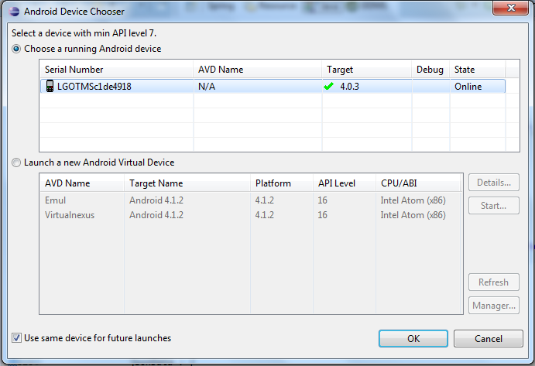

**FIG: LG OPTIMUS DEVICE**

## 3.2 EXPORTING THE .APK

If we just intend to create an apk file then, right-click on the project and select export option. 1. select the “Export Android Application” in the Android sub Menu. Refer the below figure.

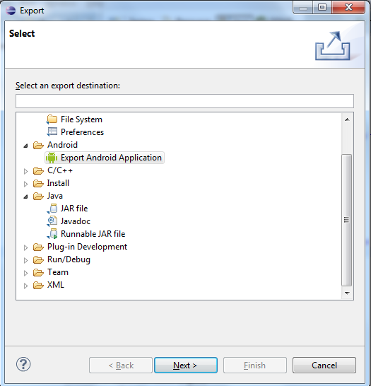

2. Click on next.

3. Browse and select the project and click next.

4. Create a new key store by browsing a location and specify a name.

5. Create a password.

6. Fill the first five fields and click on next.

7. Browse a location, where the apk has to be exported and specify the name of the

apk.

1. Click on finish. You can see the exported .apk file in the destination you selected.